**Front-End Web Programming**

**Marie Andrews & Vishnu Narayanan**

**Final Project Document**

**Quebec Farmers Shop**

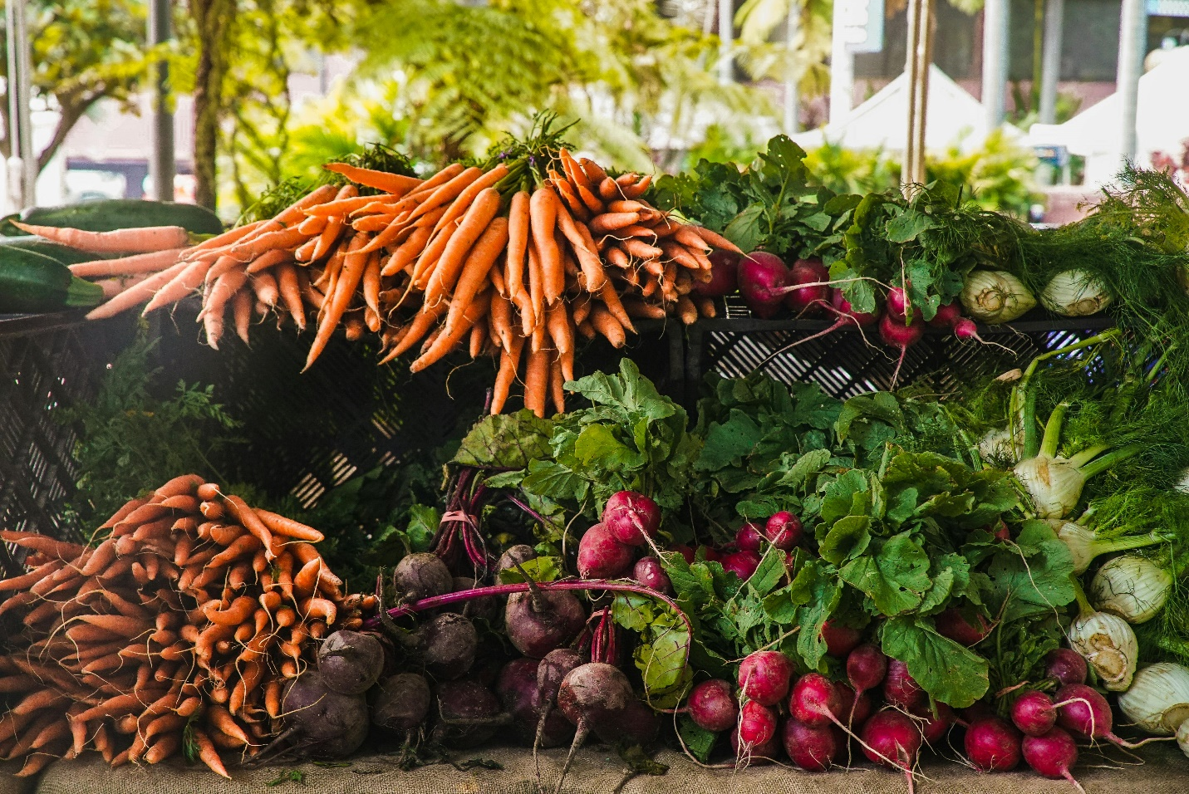

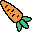     

Contents

INTRODUCTION 4

Made using: 4

Website Map: 4

CSS 4

PLANNING 5

Website Purpose 5

Website Users 5

Users’ Computing Environments 5

Ownership/Authorship of Website Information 5

Information Layout Decisions 5

ANALYSIS 6

Users’ Tasks 6

Useful Information for Users 6

Process Considerations 6

DESIGN & DEVELOPMENT 6

Number of Web Pages 6

Web Page Organization 7

Appropriate Website Structure for the Content 7

Presenting Content for Ease of Use 7

File Naming Conventions 7

Folder Structure 7

CODE 8

HOME 8

HTML CODE 8

CSS CODE 10

WEBPAGE RESULT 16

PRODUCTS 18

HTML CODE 18

CSS CODE 20

WEBPAGE RESULT 24

PURCHASE 25

HTML CODE 25

CSS CODE 28

WEBPAGE RESULT 30

BIBLIOGRAPHY 31

HTML CODE 31

CSS CODE 33

WEBPAGE RESULT 34

# INTRODUCTION

This website is the business website for the Quebec Farmers Shop, a physical and online produce and farm goods shop focusing on local and sustainably grown products. It is both an informational website and an online shop.

## Made using:

* HTML
* CSS
* JavaScript

## Website Map:

* HOME
* OUR PRODUCTS
  + PURCHASE
* PURCHASE
* BIBLIOGRAPHY

## CSS

* Separate CSS file for each page
* CSS file for whole website

# PLANNING

## Website Purpose

This website will function as both an informational ____ as well as a retail experience. Users will learn about the Quebec Farmers Shop and have the opportunity to purchase items directly online for delivery.

## Website Users

Users of this website will be the general public of Quebec, both residents and visitors, who wish to learn more about the business and/or purchase goods for delivery.

## Users’ Computing Environments

Users of this website will be accessing it via both desktop browsers and mobile browsers.

## Ownership/Authorship of Website Information

The information published on the website is authored and owned by the Quebec Farmers Shop.

## Information Layout Decisions

Decisions about if/where information goes on the website is a collaboration between developers and business owners. Pertinent information is provided by business owners and developers’ expertise is relied upon for layout choices.

# ANALYSIS

## Users’ Tasks

Users need to scroll to view the home page sections describing the Quebec Farmers Shop. Users need to left click on menu tabs to interact with the various internal links. If users wish to purchase items for delivery, they need to left click on buttons to manage item totals and their cart. A variety of filtering fields are available to assist users in searching for specific items. These include name, type, season, and color, and are accessible with left clicks as well. If the user wishes to move forward with their purchase, they need to scroll to the bottom of the Products page and left click the ‘Proceed to Purchase’ button to be directed to the Purchase tab. Alternately, the user can select the Purchase tab directly. From the Purchase page, the user will left click their choice of buttons to either go back and update their cart or confirm their purchase, at which point the user would be prompted to log in to complete purchase.

## Useful Information for Users

Users will require a working email address to complete purchase of goods, which they will be required to register with a chosen password for the website. Available product may differ between what is presented on the website and what is available in the brick and mortar storefront.

## Process Considerations

The main process for users will be navigating between available product and purchase confirmation. The steps the users will take and the needs they may have within this process were taken into consideration and informed the navigational layout of the Our Products and Purchase web pages.

# DESIGN & DEVELOPMENT

## Number of Web Pages

There are a total of 4 web pages:

* Home page
* Products page
* Purchase page
* Bibliography page

## Web Page Organization

The web pages are organized in a tab structure along the top right of the page. Users can navigate between any of the pages by selecting a tab with a left click. The main home page contains most of the informational content in a vertical layout, implementing alternating alignment for aesthetic interest.

## Appropriate Website Structure for the Content

The content lends itself to simple and direct design punctuated with fun touches (example: pointer design). The tab structure layout for internal web pages is straightforward and easy to navigate, appealing to the largest number of potential customers.

## Presenting Content for Ease of Use

The content of the website is presented in a clear, clean manner to facilitate a seamless user experience. Navigation tools and controls are clearly labelled and easily accessible.

## File Naming Conventions

This website employs conventional file naming practices. Files are given concise and clear names. Files with multi-word names use hyphens to separate words.

## Folder Structure

This website employs a straightforward folder structure to organize the necessary files. Html files are stored in the main folder. Within the main folder are separate folders for CSS and JavaScript files as well as all image files.

# CODE

## HOME

### HTML CODE

<!DOCTYPE html>

<html lang="en">

<head>

    <meta charset="UTF-8">

    <meta name="viewport" content="width=device-width, initial-scale=1.0">

    <link rel="stylesheet" href="css/index.css">

    <title>Home</title>

    <link rel="icon" href="./Images/cursor/tomato-small.png" type="image/x-icon">

</head>

<body>

    <div class="banner">

        <nav>

            <h3>Québec Farmer's Shop</h3>

            <ul>

                <a href="#">Home</a>

                <a href="products.html">Our Products</a>

                <a href="purchase.html">Purchase</a>

                <a href="bibliography.html">Bibliography</a>

            </ul>

        </nav>

        <section>

            <h1>About us</h1>

            <p>

                Welcome to Quebec Farmers Shop, your go-to destination for the freshest,

                locally-sourced vegetables and home-grown items. Nestled in the heart of Quebec,

                our shop is a proud supporter of sustainable farming and community-based agriculture.

                We are passionate about bringing the highest quality produce directly from our farms to your table.

            </p>

        </section>

    </div>

    <div class="content">

           <ul>

            <li>

                <img src="./Images/pexels-themarkdalton-439818.jpg" alt="market-stall">

                <div>

                    <h3>Our Story</h3>

                    <p>

                        Founded by a group of dedicated local farmers,

                        Quebec Farmers Shop was born out of a desire to connect our community with the wholesome,

                        nutritious food that our beautiful region has to offer.

                        Each of our farmers brings their own unique expertise and love for the land,

                        ensuring that every product we sell is cultivated with care and integrity.

                    </p>

                </div>

            </li>

            <li>

                <img src="./Images/pexels-bohlemedia-1884572.jpg" alt="woman-looking-at-veggies">

                <div>

                    <h3>Our Products</h3>

                    <p>

                        At Quebec Farmers Shop, we believe in the power of fresh,

                        seasonal produce. Our selection includes a wide variety of vegetables,

                        from crisp, vibrant greens to hearty root vegetables,

                        all grown without harmful pesticides. In addition to our produce,

                        we offer a range of home-grown items such as homemade preserves, artisanal honey,

                        and freshly baked goods, all crafted with ingredients from our farms.

                    </p>

                </div>

            </li>

            <li>

                <img src="./Images/pexels-erikscheel-95425.jpg" alt="hand-to-hand">

                <div>

                    <h3>Our Commitment</h3>

                    <p>

                        We are committed to promoting sustainable farming practices that

                        protect our environment and support the health of our community.

                        By choosing Quebec Farmers Shop, you are not only getting the best produce

                        available but also supporting local farmers who are dedicated to preserving

                        the agricultural heritage of Quebec.

                    </p>

                </div>

            </li>

            <li>

                <img src="./Images/pexels-rdne-8540981.jpg" alt="farmer-welcoming">

                <div>

                    <h3>Visit Us</h3>

                    <p>

                        Come visit us at our charming shop, where you can meet the farmers,

                        learn about our farming practices, and enjoy the freshest produce available.

                        We also offer convenient online shopping and delivery services,

                        so you can enjoy our products from the comfort of your home.

                    </p>

                </div>

            </li>

           </ul>

    </div>

</body>

<footer>

    <section>

        <p>Vishnu Narayanan</p>

        <p>Marie Andrews</p>

    </section>

    <p>Copyright 2024</p>

</footer>

</html>

### CSS CODE

@import url('https://fonts.googleapis.com/css2?family=Poppins:ital,wght@0,100;0,200;0,300;0,400;0,500;0,600;0,700;0,800;0,900;1,100;1,200;1,300;1,400;1,500;1,600;1,700;1,800;1,900&display=swap');

 ::-webkit-scrollbar {

    width: 12px;

}

::-webkit-scrollbar-track {

    background: #f1f1f1;

}

::-webkit-scrollbar-thumb {

    background: #888;

    border-radius: 6px;

}

::-webkit-scrollbar-thumb:hover {

    background: #555;

}

* {

    margin: 0;

    padding: 0;

    font-family: "Poppins", sans-serif;

    font-style: normal;

    user-select: none;

    scrollbar-width: thin; /* "auto" or "thin" */

    scrollbar-color: #888 #f1f1f1; /* thumb and track color */

    cursor: url('../Images/cursor/carrot-small.png') 0 0, auto;

}

.banner {

    color: white;

    height: 700px;

    display: flex;

    flex-direction: column;

    position: relative;

}

.banner::before {

    content: '';

    position: fixed;

    top: 0;

    left: 0;

    width: 100%;

    height: 100%;

    background-image: url("../Images/pexels-wendywei-1656663.jpg");

    background-size: cover;

    background-position: center;

    z-index: -1;

}

.banner>nav {

    box-shadow: 0 0 20px 0px black;

    background-color: darkgreen;

    position: fixed;

    top: 0;

    left: 0;

    width: 100%;

    z-index: 10;

}

.banner>nav>h3 {

    float: left;

    height: 30px;

    padding: 0 5px;

}

.banner>nav>ul {

    float: right;

    height: 30px;

    display: flex;

}

.banner>nav a {

    color: white;

    text-decoration: none;

    display: inline-block;

    font-size: smaller;

    text-align: center;

    padding: 6px 6px;

    height: 30px;

    box-sizing: border-box;

    transition: ease-in background-color 0.25s;

}

.banner > nav a:first-child {

    cursor: url("../Images/cursor/home-small.png"), auto;

}

.banner > nav a:nth-child(2) {

    cursor: url("../Images/cursor/vegetable-small.png"), auto;

}

.banner > nav a:nth-child(3) {

    cursor: url("../Images/cursor/vegetable-boxed-small.png"), auto;

}

.banner > nav a:last-child {

    cursor: url("../Images/cursor/book-small.png"), auto;

}

.banner>nav a:hover {

    background-color: rgb(43, 179, 43);

}

.banner>section {

    display: flex;

    height: 100%;

    align-items: center;

    justify-content: center;

    flex-direction: column;

}

.banner>section>h1 {

    font-size: 40px;

}

.banner>section>p {

    max-width: 800px;

    display: block;

    background-color: #00000047;

    padding: 20px;

    border-radius: 10px;

}

p {

    text-indent: 30px;

}

.content {

    margin-top: 20px;

}

.content > ul {

    display: flex;

    flex-direction: column;

}

.content li {

    display: inline-block;

    width: 50vw;

    height: 50vw;

    margin: 20px;

    box-shadow: 0 0 10px 0px;

    border-radius: 50%;

    overflow: hidden;

    transition: ease-out transform 0.25s;

    background-color: beige;

    outline: 1px solid green;

    outline-offset: -20px;

    outline-style: dashed;

    outline-width: 3px;

}

.content li:nth-child(odd) {

    margin-right: auto;

}

.content li:nth-child(even) {

    margin-left: auto;

}

.content li:hover {

    transform: scale(1.05);

}

.content li>div {

    width: 75%;

    margin: auto;

}

.content li>div>h3 {

    text-align: center;

}

.content li>img {

    height: 50%;

    width: 100%;

}

.content p {

    font-size: smaller;

}

footer {

    margin-top: 20px;

    padding: 5px;

    text-align: center;

    font-size: x-small;

    background-color: beige;

}

footer p {

    text-indent: unset;

    display: inline;

    margin: 5px 10px;

}

footer>p {

    font-weight: bold;

}

.content-other-pages {

    min-height: 700px;

    background-color: white;

    filter: opacity(0.8);

    border-radius: 10px;

    padding: 10px;

    margin: 0 50px;

    margin-top: -600px;

}

### WEBPAGE RESULT

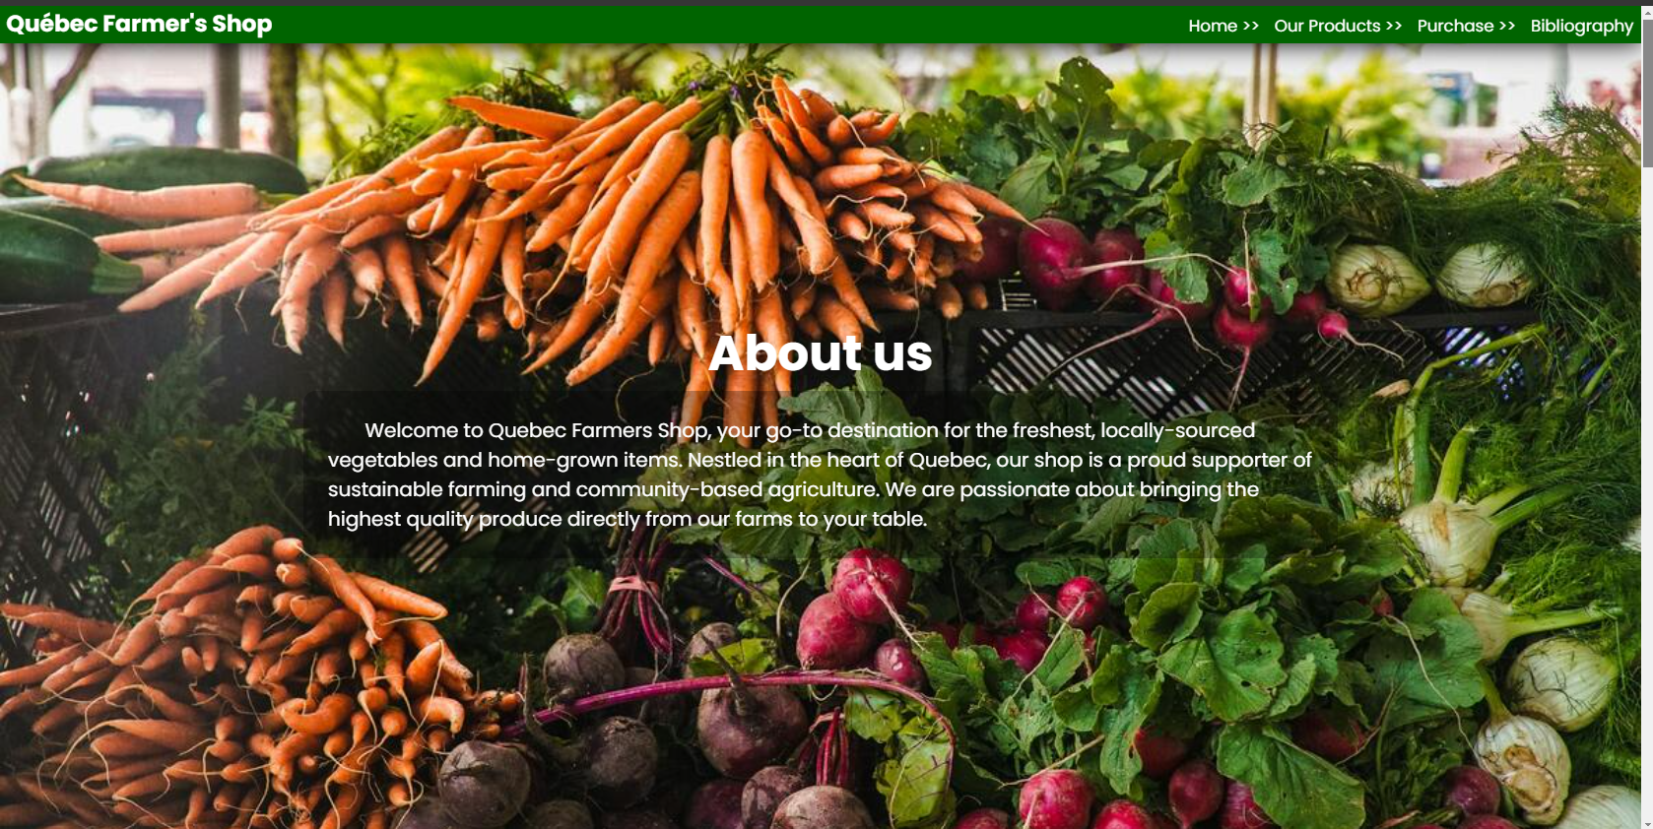

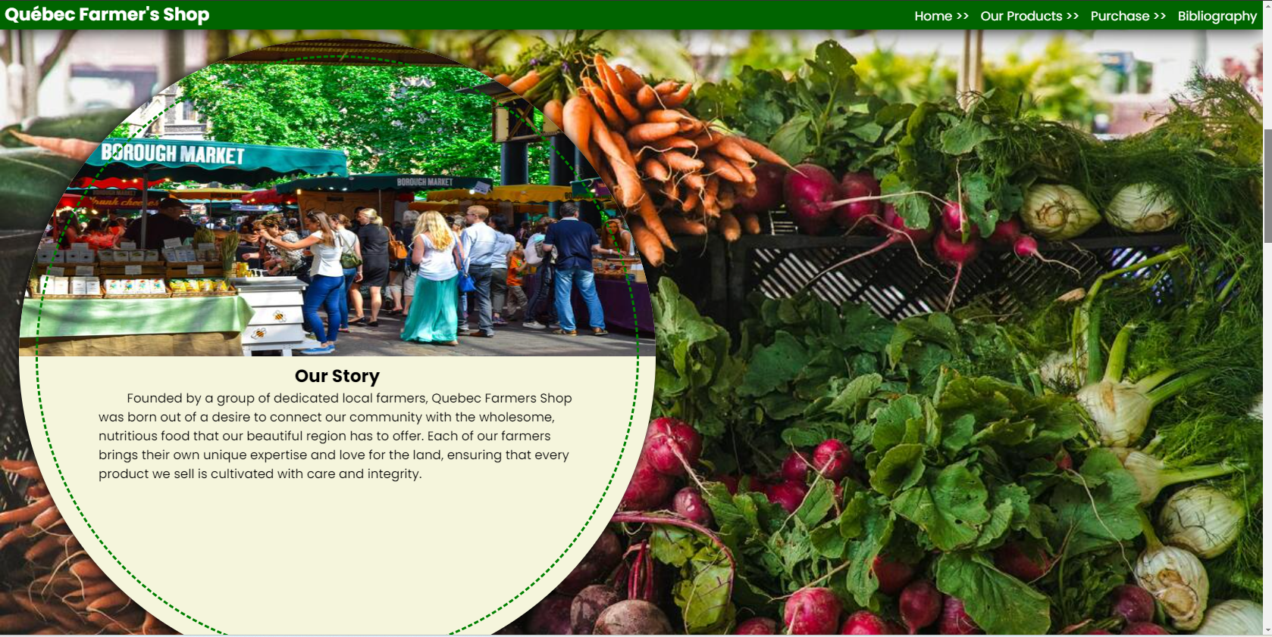

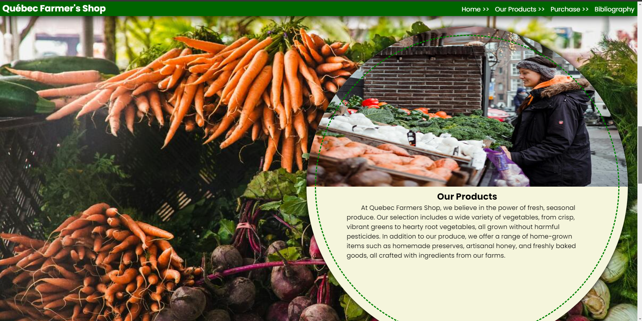

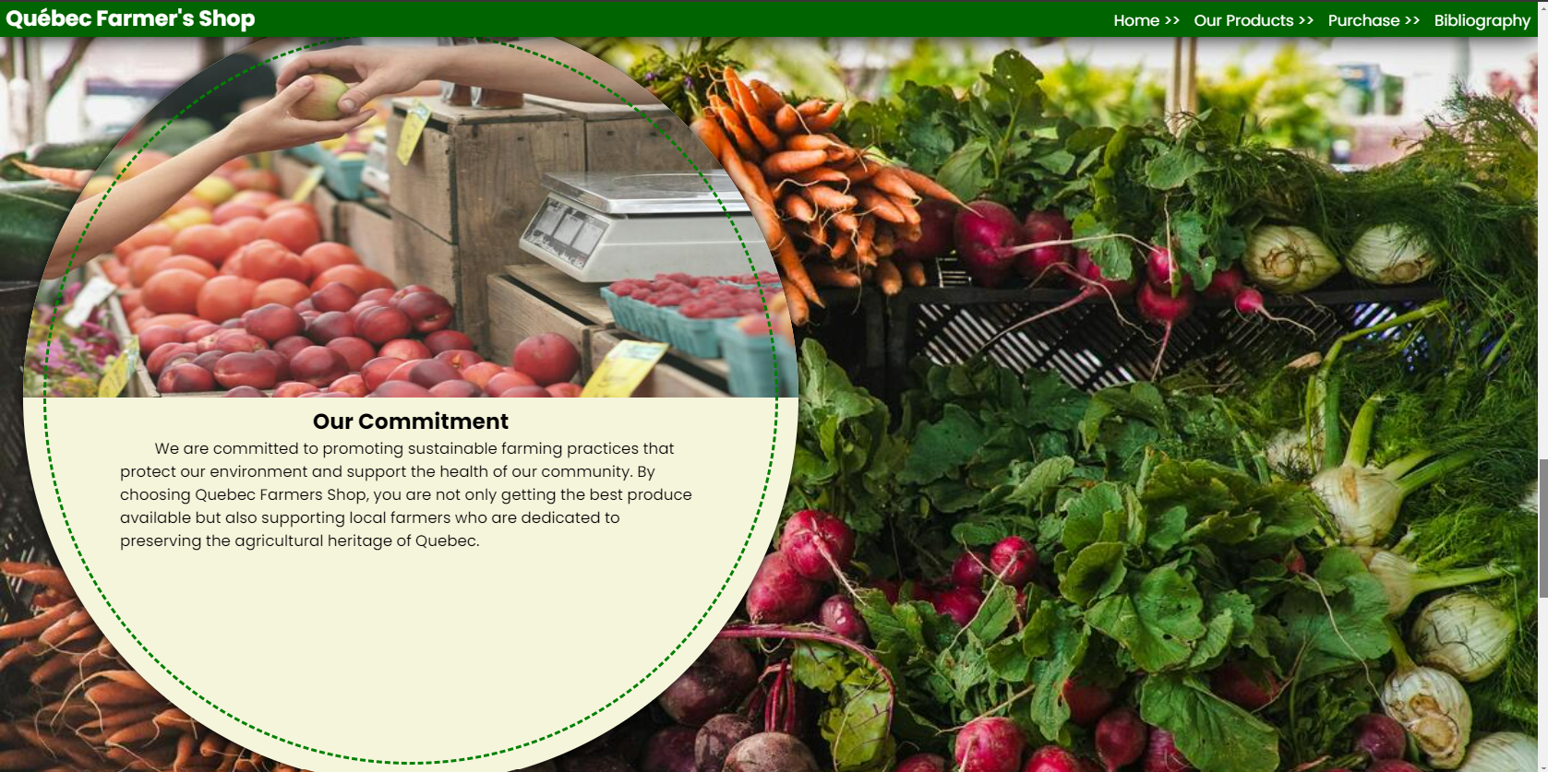

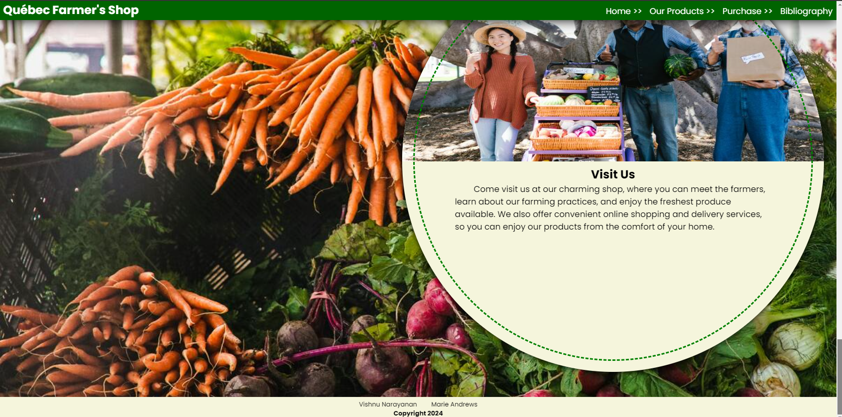

## PRODUCTS

### HTML CODE

<!DOCTYPE html>

<html lang="en">

<head>

    <meta charset="UTF-8">

    <meta name="viewport" content="width=device-width, initial-scale=1.0">

    <link rel="stylesheet" href="css/index.css">

    <link rel="stylesheet" href="css/products.css">

    <title>Products</title>

    <link rel="icon" href="./Images/cursor/tomato-small.png" type="image/x-icon">

    <script type="module" src="./js/products.js" defer></script>

</head>

<body>

    <div class="banner">

        <nav>

            <h3>Québec Farmer's Shop</h3>

            <ul>

                <a href="index.html">Home >> </a>

                <a href="#">Our Products >> </a>

                <a href="purchase.html">Purchase >> </a>

                <a href="bibliography.html">Bibliography</a>

            </ul>

        </nav>

    </div>

    <div class="content-other-pages">

        <section class="filter">

            <label>

                <b>Name(like): </b>

                <input type="text" id="filter-name">

            </label>

            <label>

                <b>Season: </b>

                <select name="" id="filter-season">

                    <option value="any">Any</option>

                    <option value="summer">Summer</option>

                    <option value="spring">Spring</option>

                    <option value="fall">Fall</option>

                    <option value="winter">Winter</option>

                </select>

            </label>

            <label>

                <b>Type: </b>

                <select name="" id="filter-type">

                    <option value="any">Any</option>

                    <option value="fruit">Fruit</option>

                    <option value="vegetable">Vegetable</option>

                    <option value="other">Other</option>

                </select>

            </label>

            <label>

                <b>Color: </b>

                <select name="" id="filter-color">

                    <option value="any">Any</option>

                    <option value="red">Red</option>

                    <option value="yellow">Yellow</option>

                    <option value="orange">Orange</option>

                    <option value="green">Green</option>

                    <option value="brown">Brown</option>

                    <option value="blue">Blue</option>

                    <option value="peach">Peach</option>

                    <option value="purple">Purple</option>

                </select>

            </label>

            <button class="button success" onclick="onSearch()">Show Search</button>

            <button class="button orange" onclick="onClear()">Show All</button>

            <button class="button success" onclick="onShowCart()">Show Cart</button>

            <button class="button danger" onclick="onClearCart()">Clear Cart</button>

            <button class="button success" onclick="onSaveCart()">Save Cart</button>

        </section>

        <section id="productsDisplayBox">

        </section>

        <button class="cta-button" onclick="proceedToPurchase()">Proceed to Purchase >></button>

    </div>

    <div id="total"></div>

    <footer>

        <section>

            <p>Vishnu Narayanan</p>

            <p>Marie Andrews</p>

        </section>

        <p>Copyright 2024</p>

    </footer>

</body>

</html>

### CSS CODE

p {

    text-indent: unset;

    font-size: small;

}

.banner::before {

    filter: blur(2px);

    background-image: url("../Images/other/pexels-rdne-8540920.jpg");

}

.filter {

    width: 100%;

    height: 60px;

    border: 1px solid;

    position: fixed;

    top: 30px;

    left: 0;

    color: white;

    background-color: green;

    padding: 15px;

    box-sizing: border-box;

}

.filter label {

    margin-right: 10px;

}

.filter button {

    border: unset;

    padding: 5px;

    margin-left: 5px;

    border-radius: 5px;

    color: white;

}

button.success {

    background-color: royalblue;

}

button.success:hover {

    background-color: rgb(49, 81, 175);

}

button.cancel {

    background-color: yellowgreen;

}

button.cancel:hover {

    background-color: rgb(99, 133, 33);

}

button.danger {

    background-color: brown;

}

#productsDisplayBox {

    display: flex;

    flex-wrap: wrap;

}

.product {

    padding: 5px;

    flex: 1 1 50%;

    max-width: 50%;

    border-radius: 5px;

    box-sizing: border-box;

    background-color: transparent;

    transition: ease-in background-color 0.25s;

}

.product:hover {

    background-color: white;

}

.product > img {

    padding: 10px;

    width: 200px;

    height: 200px;

    float: left;

}

.product > div {

    padding: 4px;

}

.product button {

    color: white;

    width: 25px;

    height: 25px;

    padding: 3px;

    border: unset;

    font-weight: bold;

    border-radius: 50%;

}

button.green {

    background-color: green;

}

button.orange {

    background-color: orange;

}

.product input {

    width: 50px;

    text-align: center;

}

#total {

    color: green;

    position: fixed;

    bottom: 30px;

    right: 30px;

    background-color: white;

    height: 100px;

    width: 100px;

    outline-offset: -10px;

    outline-style: dashed;

    border-radius: 50%;

    box-shadow: 0 0 10px 0;

    display: flex;

    flex-direction: column;

    justify-content: center;

    align-items: center;

}

.cta-button {

    color: white;

    background-color: green;

    padding: 5px 10px;

    margin: 5px auto;

    border-color: transparent;

    border-radius: 6px;

    display: block;

}

.cta-button:hover {

    background-color: rgb(2, 92, 2);

}

### WEBPAGE RESULT

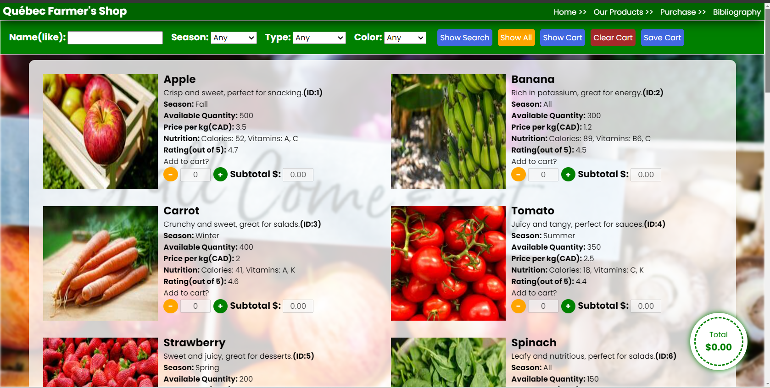

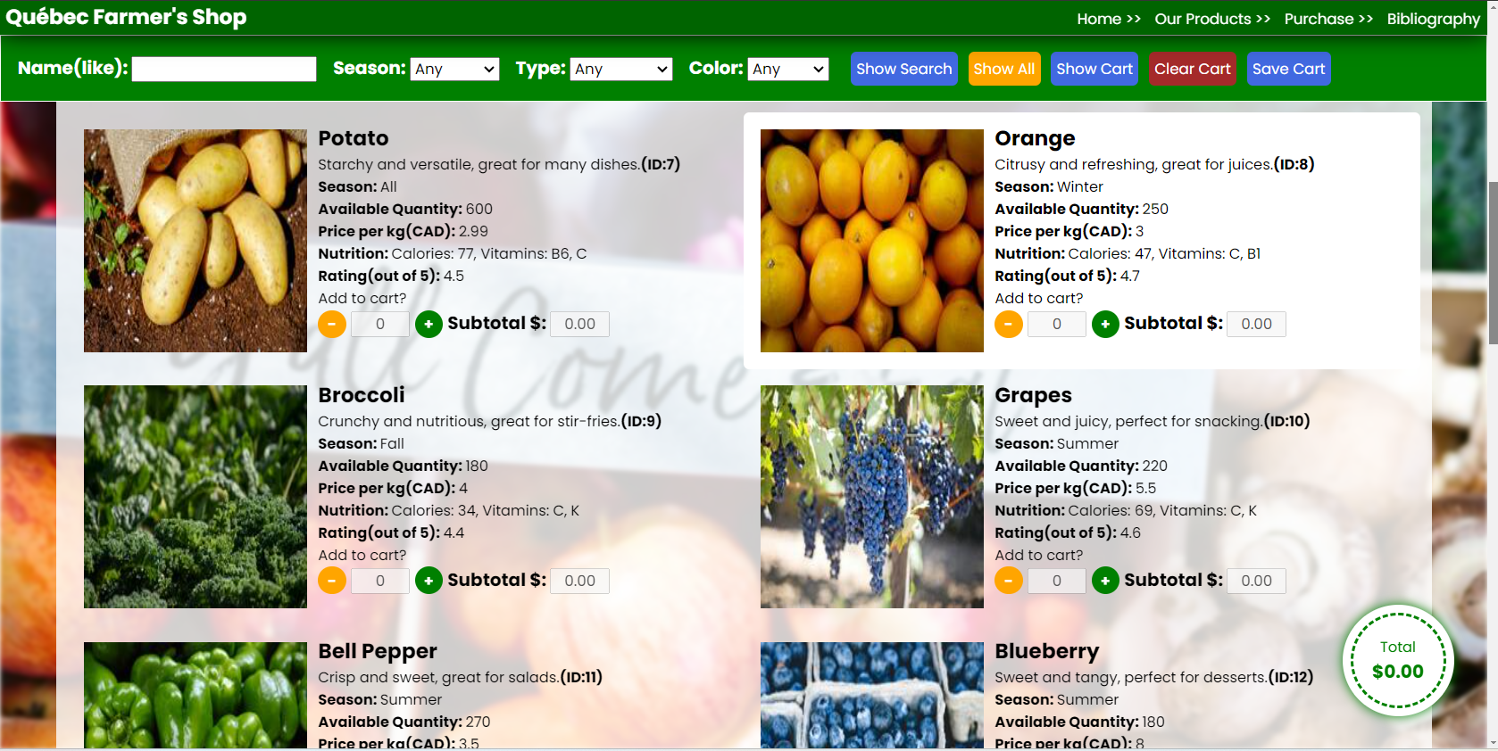

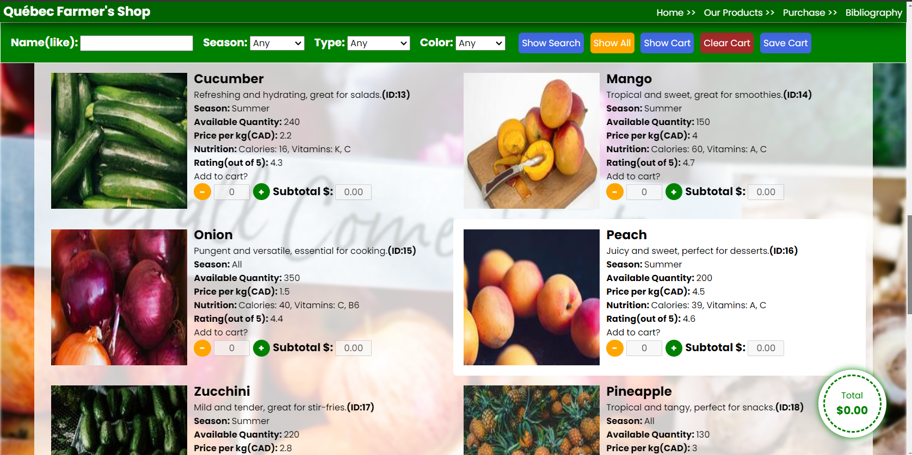

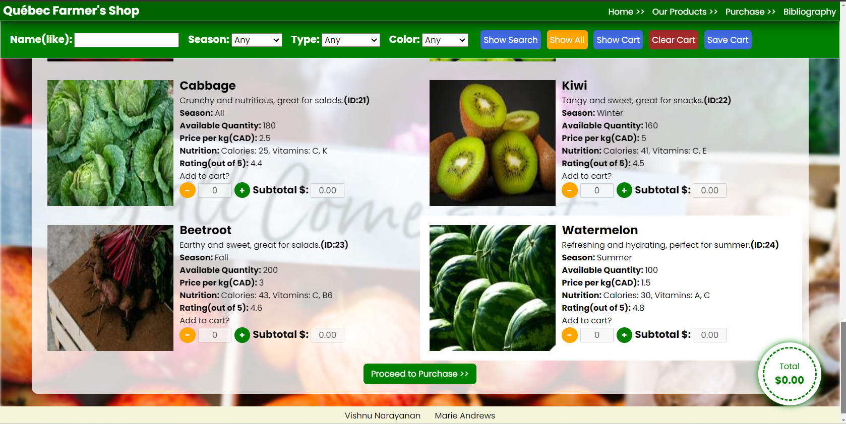

## PURCHASE

### HTML CODE

<!DOCTYPE html>

<html lang="en">

<head>

    <meta charset="UTF-8">

    <meta name="viewport" content="width=device-width, initial-scale=1.0">

    <link rel="stylesheet" href="css/index.css">

    <link rel="stylesheet" href="css/purchase.css">

    <title>Purchase</title>

    <link rel="icon" href="./Images/cursor/tomato-small.png" type="image/x-icon">

    <script type="module" src="./js/purchase.js"></script>

</head>

<body>

    <div class="banner">

        <nav>

            <h3>Québec Farmer's Shop</h3>

            <ul>

                <a href="index.html">Home >> </a>

                <a href="products.html">Our Products >> </a>

                <a href="#">Purchase >> </a>

                <a href="bibliography.html">Bibliography</a>

            </ul>

        </nav>

    </div>

    <div class="content-other-pages">

        <table class="table">

            <thead>

                <tr>

                    <th>Id</th>

                    <th>Product Name</th>

                    <th>Product Type</th>

                    <th>Product Color</th>

                    <th>Product Description</th>

                    <th>Price per kg</th>

                    <th>Available Quantity</th>

                    <th>Selected Quantity</th>

                    <th>Subtotal(CAD) $</th>

                </tr>

            </thead>

            <tbody id="table">

            </tbody>

        </table>

        <p id="message"></p>

    <div style="margin: 10px auto; width: fit-content;">

        <button class="cancel" onclick="updateCart()"><< Update Purchase</button>

        <b id="total"></b>

        <button class="success" onclick="startPurchase()">Confirm Purchase >></button>

    </div>

    </div>

    <dialog id="login-dialog">

        <div class="container">

            <h2>Login</h2>

            <table>

                <tr>

                    <td><label>Username: </label></td>

                    <td><input type="text" id="login-username"></td>

                </tr>

                <tr>

                    <td><label>Password: </label></td>

                    <td><input type="password" id="login-password"></td>

                </tr>

            </table>

            <p class="error"></p>

            <button class="success" onclick="verifyPurchase()">Log In</button>

            <button class="normal" onclick="openSignupDialog()">Register</button>

            <button class="cancel" onclick="closeLoginDialog()">Close</button>

        </div>

    </dialog>

    <dialog id="signup-dialog">

        <div class="container">

            <h2>Sign up</h2>

            <table>

                <tr>

                    <td><label>Username: </label></td>

                    <td><input type="text" id="signup-username"></td>

                </tr>

                <tr>

                    <td><label>Password: </label></td>

                    <td><input type="password" id="signup-password"></td>

                </tr>

            </table>

            <p class="error"></p>

            <button class="success" onclick="addNewUser()">Confirm</button>

            <button class="cancel" onclick="closeSignupDialog()">Close</button>

        </div>

    </dialog>

    <footer>

        <section>

            <p>Vishnu Narayanan</p>

            <p>Marie Andrews</p>

        </section>

        <p>Copyright 2024</p>

    </footer>

</body>

</html>

### CSS CODE

.banner::before {

    filter: blur(2px);

    background-image: url("../Images/other/pexels-count-chris-44396569-9524918.jpg");

}

table {

    margin: 0 auto;

    text-align: center;

    border: 1px solid green;

    border-collapse: collapse;

}

th, td {

    border: 1px solid rgb(35, 184, 35);

    padding: 8px;

}

th {

    background-color: #f2f2f2;

}

p#message {

    color: gray;

    padding: 10px;

    text-align: center;

}

button {

    margin: 5px 10px;

    padding: 5px 10px;

    border-radius: 5px;

    border: unset;

}

.success {

    color: white;

    background-color: green;

}

.success:hover {

    background-color: rgb(2, 104, 2);

}

.normal {

    color: white;

    background-color: royalblue;

}

.normal:hover {

    background-color: rgb(49, 80, 170);

}

.cancel {

    color: white;

    background-color: orange;

}

.cancel:hover {

    background-color: rgb(190, 125, 4);

}

dialog {

    margin: auto;

}

dialog h2 {

    text-align: center;

}

dialog > .container {

    display: flex;

    flex-direction: column;

    padding: 20px;

}

#login-dialog td, #signup-dialog td {

    border-color: transparent;

}

.error {

    color: red;

    height: 20px;

    padding: 5px;

    margin-bottom: 5px;

}

### WEBPAGE RESULT

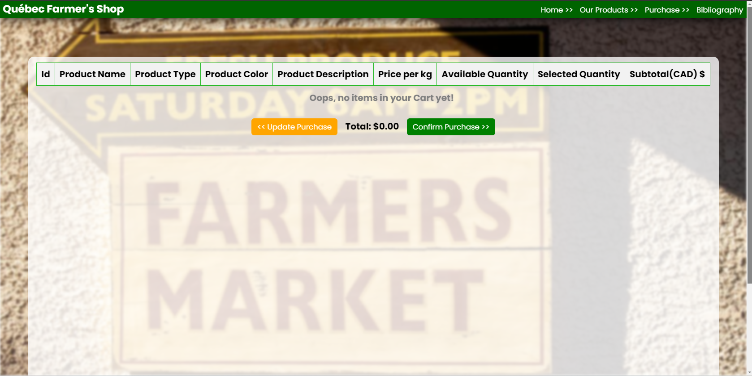

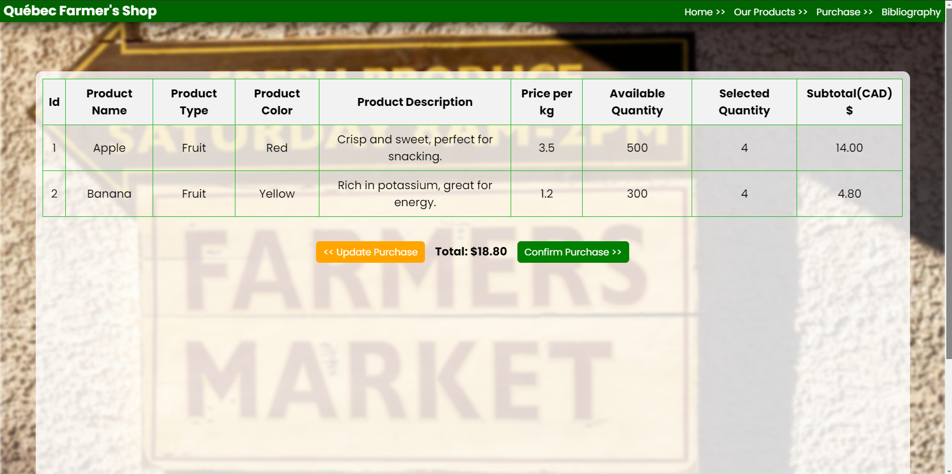

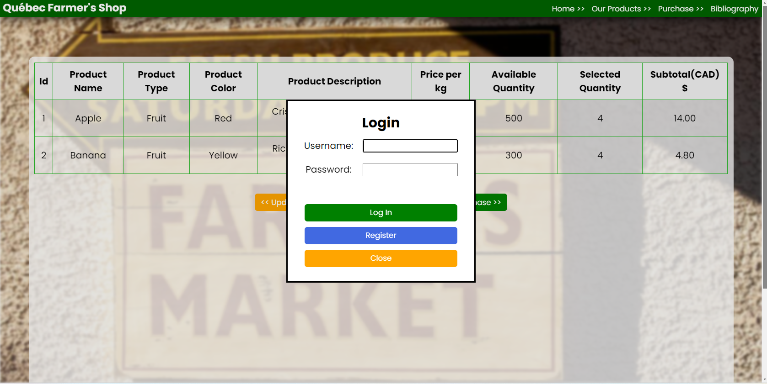

## BIBLIOGRAPHY

### HTML CODE

<!DOCTYPE html>

<html lang="en">

<head>

    <meta charset="UTF-8">

    <meta name="viewport" content="width=device-width, initial-scale=1.0">

    <link rel="stylesheet" href="css/index.css">

    <link rel="stylesheet" href="css/bibliography.css">

    <title>Bibliography</title>

    <link rel="icon" href="./Images/cursor/tomato-small.png" type="image/x-icon">

    <script type="module" src="./js/bibliography.js" defer></script>

</head>

<body>

    <div class="banner">

        <nav>

            <h3>Québec Farmer's Shop</h3>

            <ul>

                <a href="index.html">Home >> </a>

                <a href="products.html">Our Products >> </a>

                <a href="purchase.html">Purchase >> </a>

                <a href="#">Bibliography</a>

            </ul>

        </nav>

    </div>

    <div class="content-other-pages">

        <div>

            <h4>List of resources and their sources used for this project</h4>

            <ol>

                <li><a href="https://www.pexels.com/">Pictures(pexels.com)</a></li>

                <li><a href="https://fonts.google.com/">Fonts(Google fonts)</a></li>

                <li><a href="https://www.flaticon.com/free-icons/">Icons(flaticon.com)</a></li>

                <li><a href="https://www.iloveimg.com/">Image Resizing(iloveimg.com)</a></li>

            </ol>

        </div>

        <div>

            <h4>How to use this Application</h4>

            <p>

                The Home page shows the user a general idea about Québec Farmer's Shop.

                The User can choose a list of Products from that's availabe to their cart.

                Once finalized, they could go to the purchase section to confirm their purchase.

                The cart data would be preserved even if the user leaves or closes the Application

                in between. For the purchase, the user has to login, and present their credentials.

                If the user is not already registered, they could do the registering, and confirm

                their purchase. When the user goes back, the updated inventory will be reflected in

                Products page. The following section helps you reset the Application data, if needed.

                <br>

                <br>

                Note: This Application is only a demo, and not all functionalities are throughly implemented, and could also be buggy

            </p>

        </div>

        <div>

            <h4>Resetting the app would delete all data stored, which includes</h4>

            <ol>

                <li>Username and Passwords</li>

                <li>Cookies</li>

                <li>Saved Cart Items</li>

                <li>Resets Inventory Items</li>

            </ol>

        </div>

        <div>

            <img class="reset" src="./Images/icons/reset.png" alt="reset-app" id="reset-button"

                onclick="resetAppData()">

        </div>

        <div>

            <p>🙂🙂🙂🙂<b> Happy Coding </b>🙂🙂🙂🙂</p>

            <p>Thanks to my special friend for suggesting the use of emojies at the end of my project!</p>

        </div>

    </div>

    <footer>

        <section>

            <p>Vishnu Narayanan</p>

            <p>Marie Andrews</p>

        </section>

        <p>Copyright 2024</p>

    </footer>

</body>

</html>

### CSS CODE

.banner::before {

    filter: blur(2px);

    background-image: url("../Images/other/pexels-polina-kovaleva-7511833.jpg");

}

.reset {

    height: 100px;

    width: 100px;

    cursor: pointer !important;

    margin: 0 auto;

    display: block;

}

h4, p {

    text-align: center;

}

ol {

    padding: 10px;

    margin: 0 auto;

    width: fit-content;

}

.content-other-pages > div {

    margin: 20px auto;

}

### WEBPAGE RESULT

